Question 1 - Visualization and Analysis of Penguin Dataset

The Palmer penguin dataset consists of 344 records of physical attributes of three species of penguin living on three islands in Antarctica (Table 1) [ref]. In this report, consideration is given to data cleaning, including missing values, correcting imbalance and standardization. The data are explored through visualization and then analysis is carried out to compare the performance of a small number of AI approaches. In addition to a simple baseline method, the analysis consists of k-Nearest Neighbour (knn) and random forest classification, k-means unsupervised clustering method and a novel and interesting classification approach that uses insights gained from visualizations to define a classifier that is formed of a small number of separate two-dimensional support vector machine (SNM) classifiers.

Table 1. The attributes of the Palmer penguin dataset

|  |  |  |
| --- | --- | --- |
| **Feature** | **Type** | **Values in the dataset** |
| species | categorial | Adelie, Chinstrap, Gentoo |
| island | categorial | Torgersen, Biscoe, Dream |
| bill length | numerical | 32.1mm - 59.6mm |
| bill depth | numerical | 13.1mm - 21.5mm |
| flipper length | numerical | 172mm - 231mm |
| body mass | numerical | 2700g - 6300g |
| sex | categorial | Male, Female |

**Data cleaning - consideration of missing values, imbalanced data and standardization**

There are 11 records in the dataset that have missing values. Two records are missing values for all of the numerical attributes and are missing the value for the sex feature. Substituting the missing numerical values with statistically determined values was considered, but, as the physical features of the male and female of each of the species differ considerably, any amended record that this approach provides is unlikely to be statistically useful. Consequently, these two records were deleted.

The remaining nine records with missing values all have no value for the sex attribute. As can be seen in Table 2, the physical attributes of the male and female of each species are different and so it may be possible to use this difference to assign a sex to the records with missing values. The process followed was that first each of the four numerical attributes was independently standardized (to zero mean and unity standard deviation). It was then confirmed using a Shapiro-Wilk test that each attribute exhibited a normal distribution. For each record with a missing value for sex, a Z-test was performed with respect to the relevant species population to assess separately both the hypothesis that the missing sex value is Male and that it is Female. It was found that two of the records could be imputed as Male and three as Female at the 95% confidence level and these were retained in the dataset with an imputed sex attribute value. The remaining four records that failed under both hypothesis tests were removed from the dataset. The cleaned dataset had 338 records made up of 147 Adelie penguins (74 male, 73 female), 68 Chinstrap penguins (34 male, 34 female) and 123 Gentoo penguins (62 male, 61 female).

**Table 2.** Mean values for the numerical attributes for each sex of the species in the dataset, with standardized means shown in parentheses

|  |  |  |  |  |  |
| --- | --- | --- | --- | --- | --- |
| **species** | **Sex** | **bill length** | **bill depth** | **flipper length** | **body mass** |
| Adelie | Female | 37.3mm (-1.22) | 17.6mm (0.24) | 187.8mm (-0.93) | 3368g (-1.04) |
| Adelie | Male | 40.4mm (-0.64) | 19.1mm (0.97) | 192.4mm (-0.61) | 4043g (-0.20) |
| Chinstrap | Female | 46.6mm (0.48) | 17.6mm (0.22) | 191.7mm (-0.65) | 3527g (-0.84) |
| Chinstrap | Male | 51.1mm (1.31) | 19.3mm (1.07) | 199.9mm (-0.07) | 3939g (-0.33) |
| Gentoo | Female | 45.6mm (0.30) | 14.2mm (-1.48) | 212.7mm (0.84) | 4680g (0.60) |
| Gentoo | Male | 49.5mm (1.01) | 15.7mm (-0.73) | 221.5mm (1.47) | 5485g (1.60) |

**Imbalanced data**

If a dataset is imbalanced, AI approaches may favour the classes that are more common. The effect can be reduced either by deleting records of classes that are overrepresented in the dataset, or use statistical approaches to generate more records of classes that are underrepresented. The Palmer penguin dataset is somewhat imbalanced, with the number of Chinstrap records being around half of that of either Adelie or Gentoo, which are present in similar numbers. The importance of imbalance depends on the analysis method applied and it is known that all the methods adopted in the current work are generally little affected by imbalanced data. The facts that the dataset is not greatly imbalanced and that the methods adopted are known to be little affected by imbalanced data, no modifications were made to reduce imbalance in this work.

**Investigation of the island as being a confounding factor**

Figure 1 shows the distribution of species between the three islands in the study. As Chinstrap and Gentoo penguins are found only on one island, there could be a concern that when attempting to identifying species from their physical characteristics, these characteristics may be affected by an island’s environmental factors, such as predators, food supply or climate differences. In this dataset, the Adelie penguins are present on all three islands and so any effect on physical characteristics that is peculiar to one island would be likely to affect this species. Following a Shapiro-Wilk test to confirm that all of the Adelie numerical features are normally distributed, an ANOVA test was carried out to confirm that the physical characteristics of the Adelie penguins were not significantly affected by the island they inhabited. Consequently, the island inhabited by the penguins was unlikely to be a confounding factor affecting the correct identification of the penguin species.

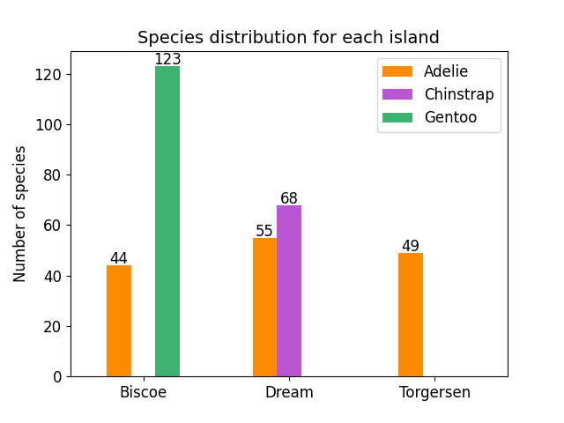

**Figure 1**. Species distribution between islands

Outliers?

**Visualization of the dataset**

Show sex differences in bodymass etc. May be useful to use them separately in distinguishing between species – I did that

Species differences in physical characteristics – these may be helpful in identifying species – which individually may be the best, but which in combination (pairwise)? Or 3 way?

Islands useful too?

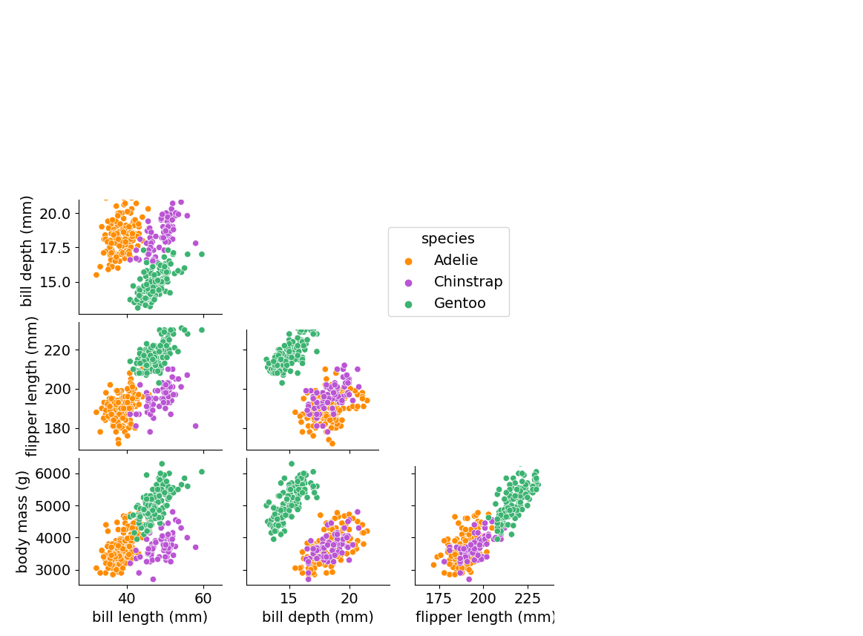

Make sure importance of sex is highlighted – as in the brief

https://github.com/ketanmakde/DT-RF_Penguin-Data-Antarctica/blob/main/Penguin%20Data%20Antarctica.ipynb

**Analysis**

The problem to identify the penguin species from the remaining features is principally one of classification. This report considers two such supervised approaches, namely knn and random forest, but an unsupervised approach is also taken, but the clusters found need to be related to the species so that the classifying accuracy can be determined. An interesting and usual approach is also described that uses a combination of the insights found from visualizations that led to the identification of a short sequence of two-dimensional linear classifications (using SVM). Regression approaches were not considered as although categorical values could be assigned numerical values, performance is likely to best if they have recognizable ordinal counterparts and this is not the case here.

For all of the approaches considered, the dataset is divided into a combined training and validation set (80% of the data – make sure it is clear that the validation set is 20% ) and a test set (20% of the data). A number of test sets were During training, a rotating set of validation data are extracted and used to tune metaparameters to derive the best performance and to reduce overfitting during training. Once suitable multiparameters have been determined, the results are obtained using the test set (20% of the data). The learning methods involve decisions to be made about the values of metaparameters in the. We took a grid approach in which a small set of values is selected across a wide range of possibles values This can allow the identification of suitable values and perhaps a second stage in which a smaller range is concentrated upon.

The relative performances of the approaches are assessed using accuracy (percentage of correct predictions in the test set) and confusion matrices, so that the number of misidentifications for specific species can be seen and this may be useful in tuning models? Methods that used precision either directly or as part of the metric (such as Recall and F1-Score) were not considered as these are generally more useful if the cost of false negatives is high, which was not found in the current work.

Mean of random sets 1 to 10, from best result of each of the grid

unbalanced

----------

knn robust

logistic regression not

random forest robust

svm can be affected

k-means inbalance not relevant

***Baseline method***

A baseline is the simple prediction used to assess performance improvements that can be achieved by the algorithms being considered. If the performance cannot be improved significantly above the baseline then this may indicate that the approach being considered is not suitable or that the problem is particularly difficult. It also gives a basis for the comparison of principal methods being considered. In a classification problem, the baseline is often to select the class that has the most observations, in regression the mean or the median I used and in unsupervised learning perhaps a random assignment of data values to clusters is made. In this work the Adelie penguins are the most common (147/388), giving an accuracy of 37.9%. Other methods in this study will be compared with this baseline figure.

***Classification method 1 - k-Nearest Neighbour (kNN)***

kNN is biased towards features with smaller standard deviations, so the data were standardized, before the results were obtained. Using the approach described above, the following metaparameters were tuned using a *rotating???* training and validation set (describe params)

***Classification method 2 - Random forest***

No need to standardize. Using the approach described above, the following metaparameters were tuned using a *rotating???* training and validation set (describe params)

***Clustering method - k means***

For k-means clustering, standardization or normalization of features is often recommended. This is because k-means clustering relies on calculating distances between data points to assign them to clusters.

Using the approach described above, the following metaparameters were tuned using a *rotating???* training and validation set (describe params).

Need a nice image showing the clusters in the test set and how these matched to the classes of the samples. – can we do 3d??

k-means operates with numerical values not categorical data. So, we only look at the numerical values. The performance of the classification could potentially be improved by producing one set of clusters for male and another for females and then using the value of this feature to determine which cluster to use when identifying a new input.

***Something surprising and unusual - a combined visualization and analysis approach***

In this approach, visualization of pairwise combinations of the numerical data, combined with a short sequence of simple two-dimensional linear classifiers based on SVMs was found to be able to produce results of accuracy at least as good as the approaches investigated in the previous section.

While this approach may take more effort, in that deeper understanding of the nature of the dataset needs to be obtained, the approach is not a ‘black box’ (classification approaches are frequently treated in this way with little underlying knowledge of either the data or the methods being adopted. The drawback of the approach taken is that it is not applicable generally as it may not always be feasible to extract the necessary insights from just pairs of combinations and the nature of the data may not be revealed without resorting the multi-dimensional approaches of the better know classification methods considered in the previous section. Also, it will become more difficult to use this approach as the number of features is increased.

Perhaps could be continued with further features????

Why does removing a feature improve performance?

REMOVING features can improve performance…

random forest, no island,98.82%

|  |  |
| --- | --- |
| **Method** | **Accuracy** |
| baseline, most numerous species | 37.9% |
| kNN, all features | 82.35% |
| kNN, no island, no body mass | 97.65% |
| random forest, all features | 98.97% |
| random forest, no island, no body mass | 98.97% |
| k-means, all features | 97.06% |
| k-means, no body mass* | 97.06% |
| Surprising, no island, no body mass | 98.00% |
| Surprising, no body mass | 97.27% |

Confusion matrix to show that confusion is between Adelie and ?.

*categorical not involved

**Conclusions**

Nice things about my method. Careful to carry out AI in such a way that it is robust. Good idea generally, not just because of my method.

The SVM approach is shown to produce accuracy results at least as good as the other analysis methods applied in this work, although clearly the approach is specific to this particular application.

You should consider how to visualize the data and which algorithms to

try. Nothing you do will be completely successful, this coursework is

not here to judge your final accuracy but the care you bring to your

investigation. Here are some thing you should consider:

\begin{itemize}

\item The kind of algorithm to use, for example whether to classify, regress or cluster.

\item The metric to use to measure the performance of the model.

\item What sort of baseline to compare the model to.

\item How to choose the hyperparameters of your model.

\end{itemize}

For good marks you should include some graphs that illustrate

properties of the data and you should compare two classification

algorithms, both to each other and to a baseline model. The algorithms

you pick do not need to be unusual, for example $k$nn classification

would be perfectly good, though, of course, for full marks this would

include some consideration of how to pick $k$ and how to measure the

distance, though, as you know, no approach to chosing $k$ is every

going to be completely satisfactory. In addition, you should include

either some exploratory regression or unsupervised learning; for

regression you might regress two properties and examine whether the

regression parameters are the same for each penguin type; unsupervised

learning could use $k$-means, for example. You do not need to do both

regression and unsupervised learning.

You should make sure any assessment is not restricted to the data used

in train models or decide on metaparameters. In your report you should

explain your decisions. You code will not be marked for elegance, but

it should run correctly; it is expected you will use Python, but any

of Python, Julia or R is fine. Do not include screenshots of graphs,

they should be imported directly; resize them to the correct size

before importing them, if the labels are tiny the graphs will not be

marked. Make sure figure captions are descriptive, it is better to

have some overlap between figure captions and the main text than to

have figure captions that are not reasonably self-contained.

As a rough guide to marking:

\begin{itemize}

\item Initial description of the data, including some graphs or other approaches to visualisation. 6 marks.

\item Either unsupervised learning or regression. 6 marks.

\item Two algorithms should be tested, if only one algorithm is

included the 28 available marks will be halved.

\item Overall presentation (3 marks), including use of appropriate

sections, plots, diagrams, or tables to make your point. Do not

include code snippets in the report. Instead, describe in words or

equations what you are implementing. Format equations correctly.

\item Suitable choice of algorithms (4 marks).

\item Suitable choice of evaluation for algorithms (3 marks).

\item Comparison with a suitable baseline (3 marks) and a justification for which baseline to use.

\item A description of metaparameter selection (3 marks), if one

algorithm has not metaparameter, then explain that and note why not

and why this do or does not make it a better algorithm for these

data.

\item Describe and compare the results from your two algorithms,

include a description of how you implemented the algorithms. (6 marks)

\item There are some marks (6 marks) for something suprising and unusual.

\end{itemize}

\section*{Question 2 - Ethical challenge facing us in data science and AI}

For two of these three types of ethical challenge facing us in data science and AI:

\begin{enumerate}

\item The protection of data, of the people whose data they are and participants in any study.

\item Avoiding the amplification of biases and regressive values implicit in historic dataset.

\item The safety of AI systems and the possible of existential threats from machines.

\end{enumerate}

describe what you think is a specific example of a challenge that

could arise or has arisen in the past. Obviously the three broad types

of challenge overlap, do not worry about the boundaries between these

types, but do try to address different types of threat in your

examples. Explain how the ethical problems could be addressed, or at

least made more transparent.

\subsection*{Report}

Your report should be no longer than five pages, including any

references. It is expected that Question 2 would occupy about a fifth

of this space; use an 11 or 12pt font and do not try tricks like

expanding the margin to fit in more text, shorter is better than

longer.

Your report must be submitted in pdf and should be prepared in LaTeX;

overleaf is a good approach, but not required as long as LaTeX has

been used. As always when using LaTeX, give yourself over to defaults,

our expectation of what a document should look like has been

conditioned on LaTeX, so it is best not to try to override the look of

the document.

Avoid code snippets in the report unless that feels like the best way

to illustrate some subtle aspect of an algorithm; do always though

consider a mathematical description if possible. You will be asked to

submit code and it may be tested to make sure it works and matches

your report. It will not, however, be marked in and of itself.

\subsection*{knn}

Perhaps use F1-score (there are others!) as the classes are imbalanced in number?

F1-score is a metric that considers both precision and recall. Precision measures the accuracy of positive predictions (TP/(TP+FP)), while recall (also known as sensitivity) measures the fraction of positives that were correctly identified (TP/(TP+FN))

F1-score is the harmonic mean of precision and recall and is calculated as follows:

F1 = 2x(PrecisionxRecall)/(Precision+Recall)

F1-score ranges from 0 to 1, where a higher value indicates better model performance. F1-score is particularly useful when classes are imbalanced because it considers both false positives and false negatives.

\section*{Report template}

This is a report template, you don't need to use this template, but do

use it if it is helpful.

Here is an example of an equation:

\begin{equation}

\pi=4\left(1-\frac{1}{3}+\frac{1}{5}-\frac{1}{7}\ldots\right)

\end{equation}

or

\begin{equation}

\pi=4\sum_{n=0}^\infty\frac{(-1)^{n}}{2n+1}

\end{equation}

where $\pi$ can be written in line by using \$'s. Here is a vector:

\begin{equation}

\mathbf{x}=\left(\begin{array}{c}x_1\\x_2\end{array}\right)

\end{equation}

<https://machinelearningmastery.com/how-to-get-baseline-results-and-why-they-matter/>